Activating the SNTP option in a PT5300.

Before you begin please power off the PT5300.

To enable the SNTP option in a PT5300 you need to move the cable connected to XK1 on the main board (marked 1 in fig. 1) to the unused connector on the GPS board. (Marked 2 in fig. 1.).

No software changes is necessary to enable the SNTP option.

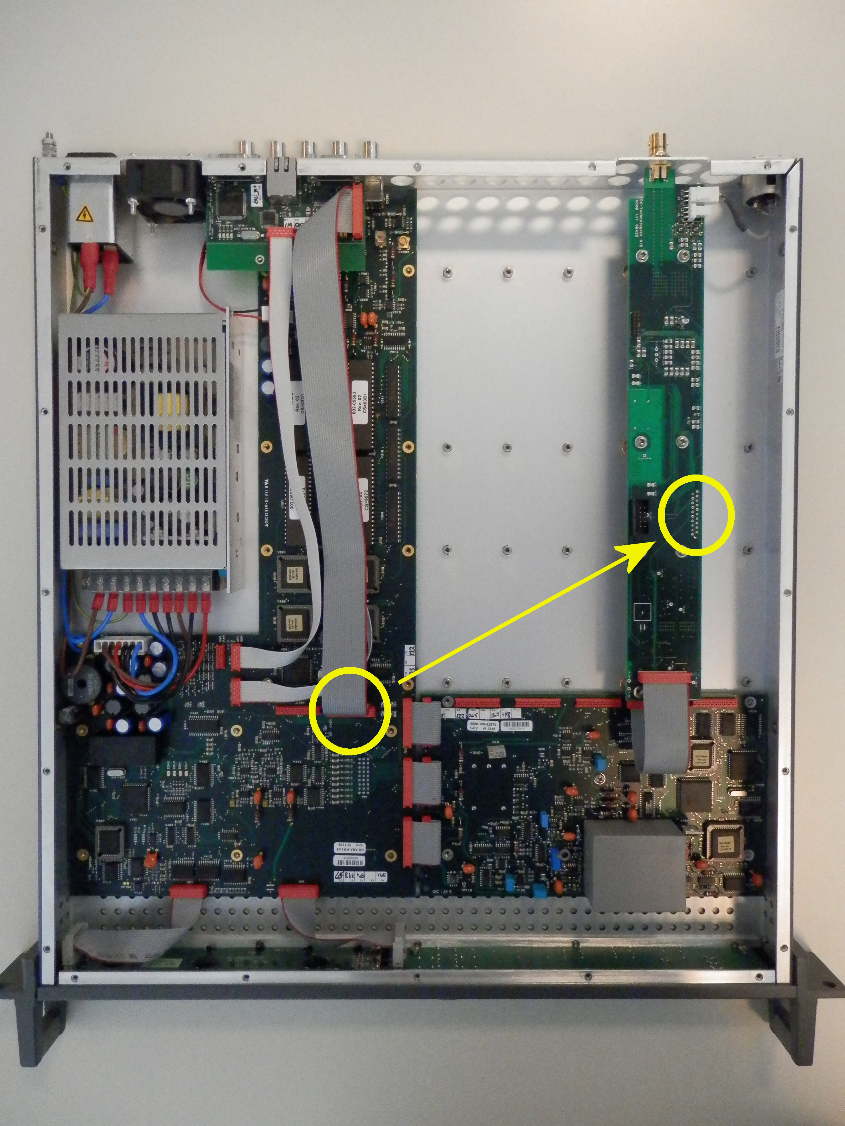
Figure 1.
1.
2.

When connecting the cable to the GPS board you must make sure that the plastic polarization pin lines up with the hole in the PCB as shown in fig. 2 and fig. 3.

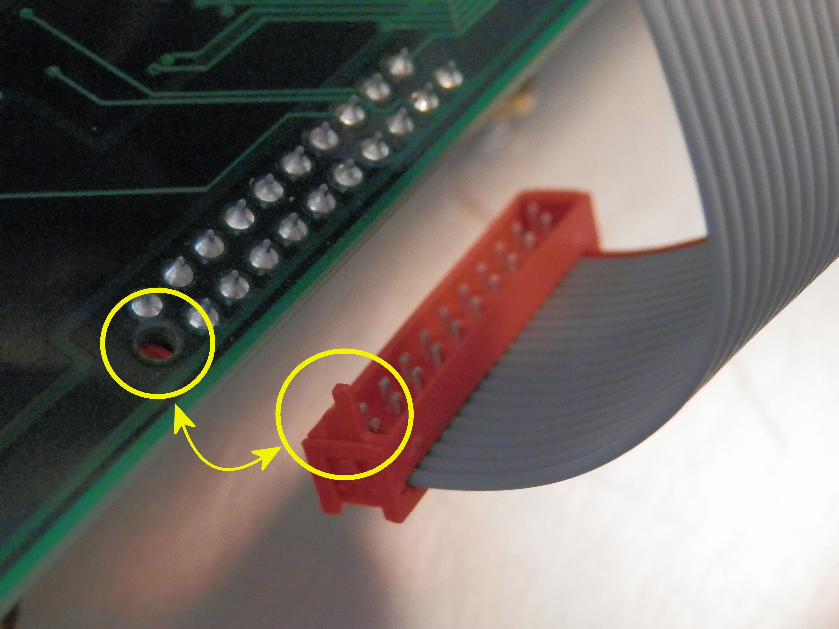
Figure 2.

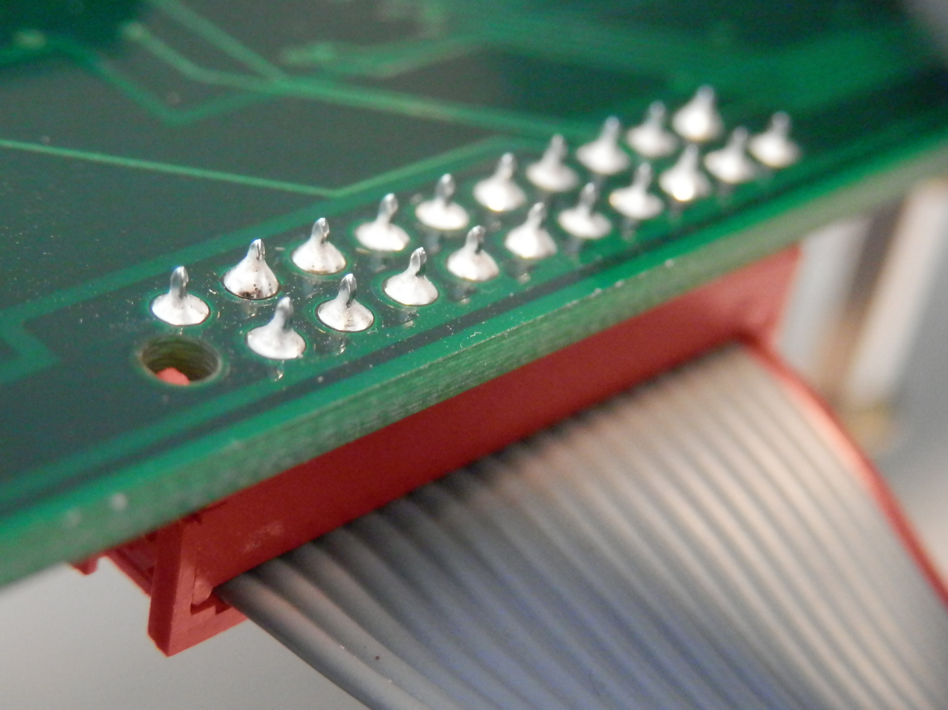
Figure 3.
In figure 4 the PT5300 is shown with the SNTP option enabled using a 35 cm. cable.

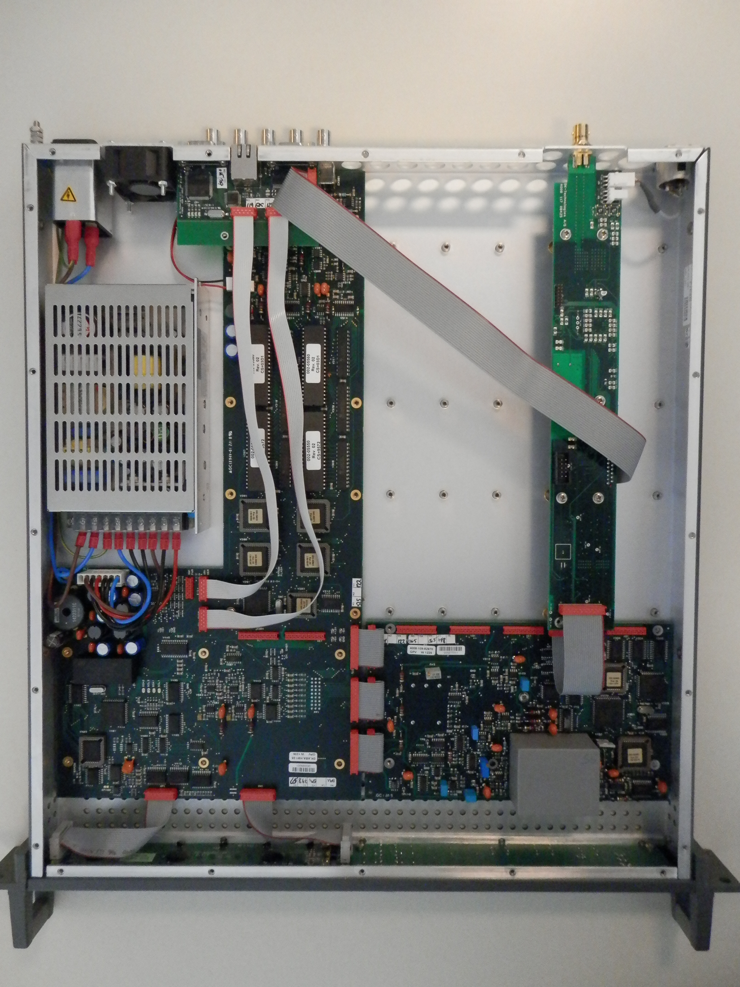
Figure 4.
Normally the SNTP option is enabled using a 40 cm. cable as shown in figure 5.

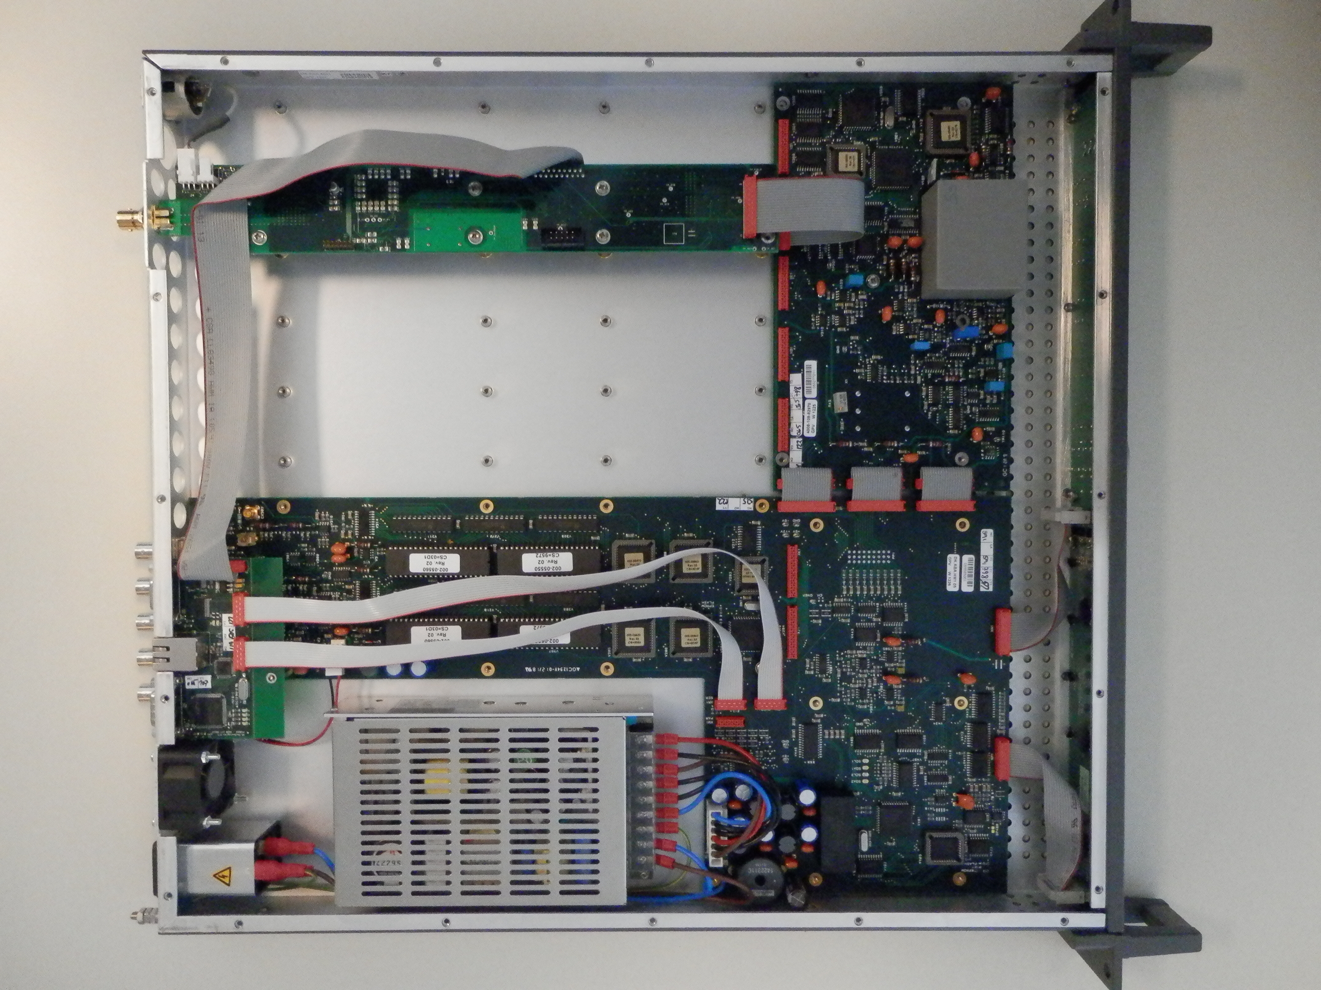
Figure 5.

